**Introduction to OS &**

**Linux**

**National University of Computer and Emerging Sciences, Lahore**

**Operating System Lab (spring 2021)**

**Lab Instructors: Zumirrah Khalid**

**On Computer Startup**

• Power-on self test (POST) checks for errors

• CPU

• Memory

• Basic input-output systems (BIOS)

• BIOS/firmware

Activates the computer’s hard disk drives

• Bootstrap loader

• First piece of the operating system

• Has a single function to load the operating system into memory

**Operating System**

• What is Operating System?

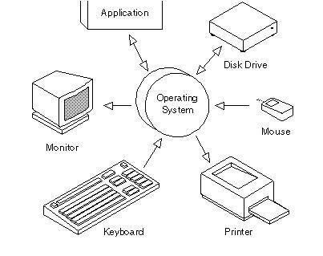Supports computer’s basic functions

• What tasks an OS Perform?

• Processor management

• Memory management

• Device management

• Storage management

• Application interface

• User interface

• Types

• Linux

• Windows 8, Windows 7, Vista, XP

• Mac

**What is Linux?**

• A fully-networked 32/64-Bit Unix-like Operating System

• Compilers Like C, C++

• Multi-user, Multitasking

• Coexists with other Operating Systems

• Includes the Source Code

• Open Source

**Why is it significant?**

• Growing popularity

• Powerful

• Runs on multiple hardware platforms

• Users like its speed and stability

• No requirement for latest hardware

• It is free

• Licensed under GPL (General Public License)

**System Structure**

**Applications**

**Shell**

**Kernel**

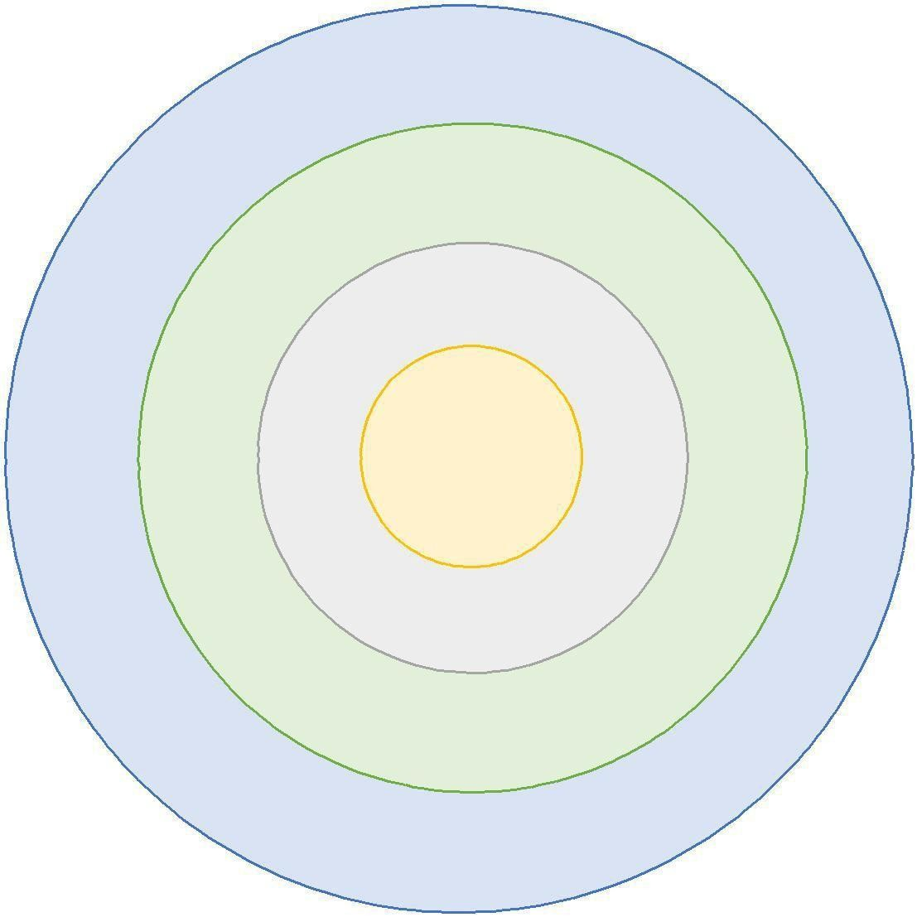**Hardware**

**The Linux System**

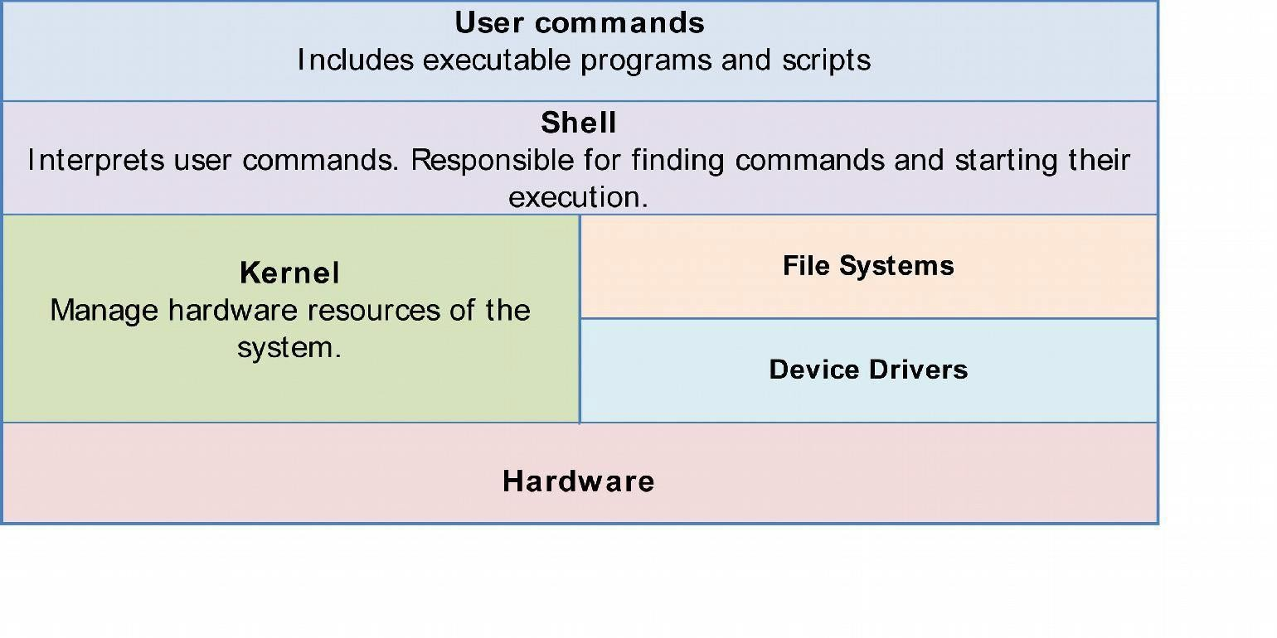

**Linux Command Basics**

• To execute a command, type its name and arguments at the command line

• <*command_name*><*space*><*options*><*space*><*arguments*>

**ls -l /etc**

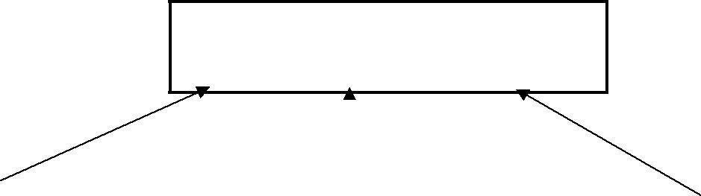

Command name Arguments

Options

(flags)

**Editors**

Several choices available:

• **vi** Standard UNIX editor

• **the** XEDIT-like editor

• **xedit** X windows text editor

• **emacs** Extensible, Customizable Self-Documenting Display Editor

• **pico** Simple display-oriented text editor

• **nedit** X windows Motif text editor

**The file system**

/



/dev / etc /usr /bin UNIX /home /tmp

/var

/mydir

manua book

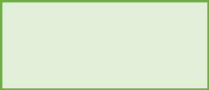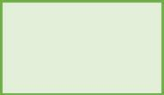

**Special Files**

• /home - all users’ home directories are stored here

• /bin, /usr/bin - system commands

• /etc - all sorts of configuration files

• /var - logs, spool directories etc.

• /dev - device files

• /proc - special system files

**Windows**

* The directories in MS-DOS path are separated by ‘\’
* File names are case insensitive.
* Where DOS/Windows had various partitions and then directories under those partitions.
* An executable is one with an extension of .exe, .com or .bat.
* You can set attributes to make file read only, hidden.

Linux

* Paths are separated by ‘/’.
* File names are case sensitive.
* .There is only a single hierarchal directory structure (resembles a tree). Everything starts from the root directory,represented by '/', and then

expands into sub-directories.

* Any file whose execute permission is turned on is executable
* You can set permissions on a file

**Virtual Machine**

• What is a virtual machine?

• VirtualBox and VMWare

• ISO files – Ubuntu ISO file

• Ubuntu installation on VirtualBox or VMware

**Some commands for Beginners**

• Clear the console

• clear

• Changing working Directory

• cd Desktop

• cd Home

• List all files in directory

• ls

• Copy all files of a directory within the current work directory

• cp dir/* .

• Copy a directory within the current work directory

• cp -a tmp/dir1 .

• Look what these commands do

• cp -a dir1 dir2

• cp filename1 filename2

To make archive of existing folder or files

• tar cvf archive_name.tar dirname/

• tar cvf alldocs.tar *.txt

Extract from an existing tar archive.

• tar xvf archive_name.tar

View an existing tar archive.

• tar tvf archive_name.tar

o ls show files in current position

o cd change directory

o cp copy file or directory

o mv move file or directory

o rm remove file or directory

o pwd show current position

o mkdir create directory

o rmdir remove directory

o less, more, cat display file contents

o man read the online manual page for a command

o whatis give brief description of a command

|  |  |  |
| --- | --- | --- |
| o | su | switch user |
| o | passwd | change password |
| o | useradd | create new user account |
| o | userdel | delete user account |
| o | mount | mount file system |
| o | umount | unmount file system |
| o | df | show disk space usage |
| o | shutdown | reboot or turn off machine |